**Cadder Parish Church**

**Intimations and News – 30.3.25**

**Welcome** to everyone here for our Morning Service. The service is led by our minister, Rev John MacGregor and Music led by Jose Javier Ucendo Malo (MMUS). Tea and Coffee will be served after the service in our North Hall. If you would like to help serving the teas and coffees or read a lesson a Sunday, there are sheets in the vestibule.

**Funerals** It is with sadness that I intimate the passing of Bob Burnett. Bob died on the 24th of March. Bob was a past session clerk; he was very involved in different building projects and was committed to his faith and Cadder Church. Bob`s service will be held on the 28th April at Cadder Church at 11.45 am

It is with sadness that I intimate the passing of Edith Adam who died on the 21st of March; her funeral service is on the 9th April at 2p.m at Bishopbriggs Crematorium.

I commend both families to your prayers.

**Cadder Coffee Shop & Shop**

**The Coffee Shop is open on Tue – Thur - 10-2 and Friday 10-12 – All are welcome to come and enjoy good food and fellowship.**

**Guild** Our final meeting of the session is our Daffodil Tea on Thursday 3rd April at 7pm in the South Halls. Kirsty Duncan a Professional Singer is coming to entertain us. Cost to members is £2.00. There are a few available spaces if anyone would like to join us but please speak to a member of committee if you intend to do so.

**Kirk Session Meeting –** Monday 31st March 7.30 p.m in the North Hall

**Intimations** - If you would like your organisation or event intimated on the screen, if you could have it with the minister by Tuesday evening.

**FOODBANK** - If you wish to donate to the local foodbank, you can bring your donations of food to the church

**Early Fellowship** on ZOOM and inperson at the South Hall – Tuesday and Thursday at 9.30 am

**The “Pastoral Post” box** is available in the vestibule. If you wish to highlight someone in need of a visit, phone call, flowers or a prayer please put their details on a card and post it into the box

**212th Boys Brigade**

**212th Glasgow Boys’ Brigade – Cadder Parish Church**

**Email:** [**info@212glasgow.co.uk**](mailto:info@212glasgow.co.uk)

**P1-3 Monday 6-7pm P4-6** **Monday 7.15-8.30pm P7-S6 Friday 7-9pm**

**92nd Girls’ Brigade Company**

**Meeting times**

**Explorers P1 to P3 6.15pm till 7.30pm**

**Juniors P4 to P7 6.30pm till 8.00pm**

**Brigaders S1 to S6 7.00pm till 8.30pm**

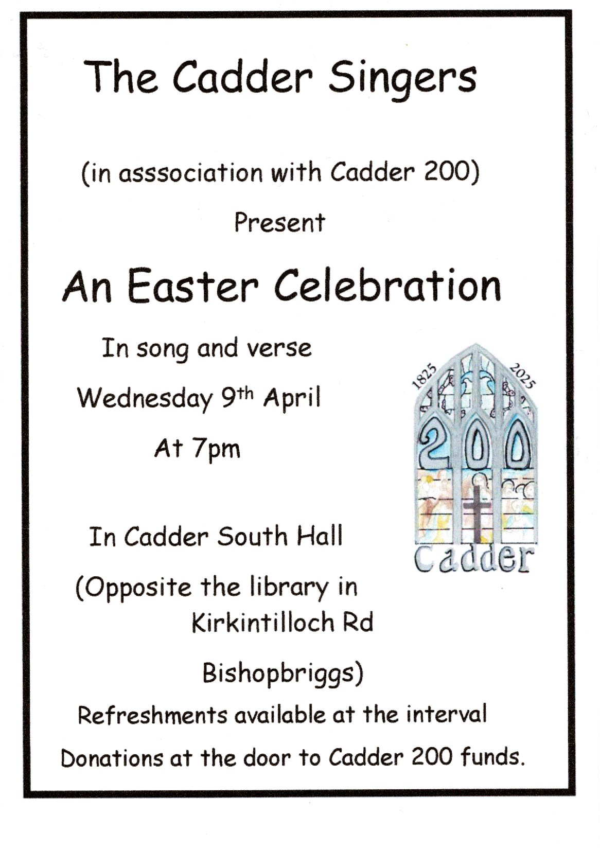

**CADDER 200 CONCERT**

Glasgow Philharmonic Choir   
4th April – 7.30pm in the Sanctuary

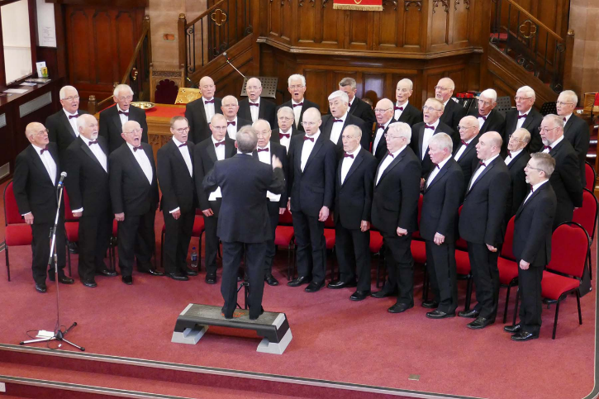

**LENT 4 REFLECTIONS**

**WEEKLY TILL EASTER ON**

**SUNDAY 30th MARCH 7-8 PM - SOUTH HALL**

Christian Aid Resources for Lent – Act on Poverty

**WEDNESDAY 2nd April IN THE SOUTH HALL CHAPEL**

**11.30am -12Noon**

Beginnings and Endings



Next Week is the last Sunday to bring your eggs to the Church

